Progress Note Patient __________________________ Date ______________

Main Pain Complaints (list up to 3 main pain complaints and the pain score for each since your last visit)

For this complaint my pain was (0-10) ___/10 for ____ days, then (0-10) ____/10 for ____ days. Pain now (0-10) ___/10

For this complaint my pain was (0-10) ___/10 for ____ days, then (0-10) ____/10 for ____ days. Pain now (0-10) ___/10

3.

For this complaint my pain was (0-10) ___/10 for ____ days, then (0-10) ____/10 for ____ days. Pain now (0-10) ___/10

Other comments:

Adverse Effects
Please check any that apply.
None Mild Moderate Severe None Mild Moderate Severe
Constipation |  |  |  |  | Sedation
Itching |  |  |  |  | Sexual dysfunction
Sweating |  |  |  |  | Decreased libido
Nausea/vomiting |  |  |  |  | Other_____________
Diarrhea |  |  |  |  | _________________
Reflux |  |  |  |  | _________________

Notes:

Analgesia
Brief Pain Inventory – Modified
On the diagram below, shade in the areas where you feel pain. Put an X on the areas where it hurts the most.
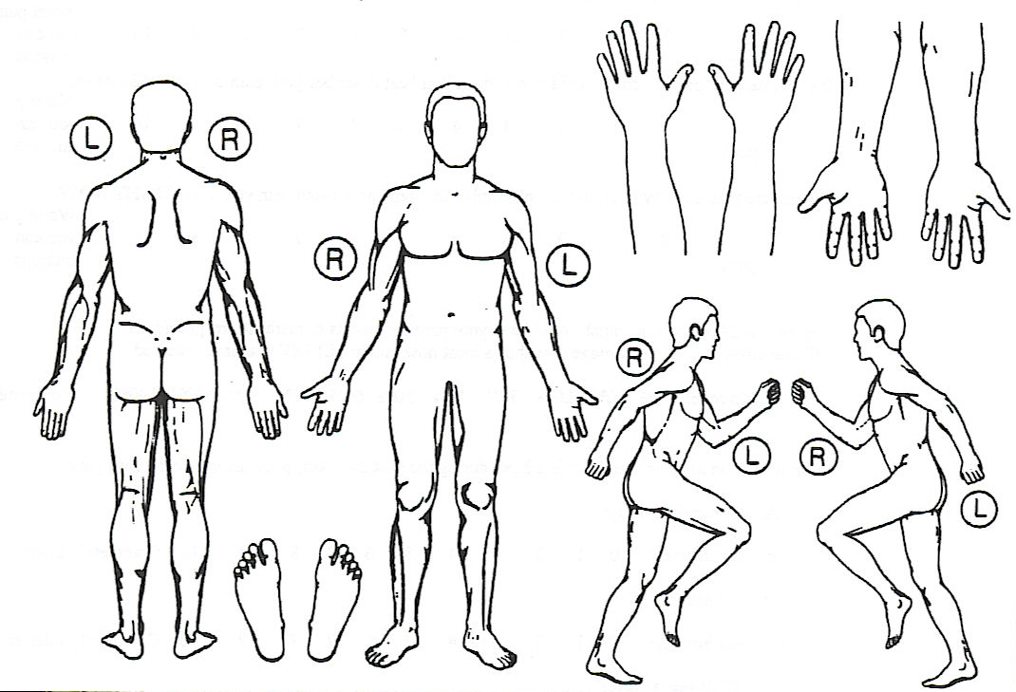

Please rate your pain by circling the number that best describes your pain at its WORST since your last visit.

No Pain 0____1____2____3____4____5____6____7____8____9____10 Worst Pain

Please rate your pain by circling the number that best describes your pain at its LEAST since your last visit.

No Pain 0____1____2____3____4____5____6____7____8____9____10 Worst Pain

Please rate your pain by circling the number that best describes your pain at its AVERAGE since your last visit.

No Pain 0____1____2____3____4____5____6____7____8____9____10 Worst Pain

Activities of Daily Living
PHQ-9

Please answer every question to the best of your ability unless you are requested to skip a question.

Over the last 2 weeks how often have you been bothered by the following problems. | not at all  0 | several days  1 | more than half the days  2 | nearly every day  3
A) Little interest or pleasure in doing things
B) Feeling down, depressed or hopeless
C) Trouble falling or staying asleep, or sleeping too much
D) Feeling tired or having little energy

E) Poor appetite or overeating

F) Feeling bad about yourself, or that you are a failure, or have let yourself or your family down
G) Trouble concentrating on things, such as reading the newspaper or watching television
H) Moving or speaking so slowly that other people could have noticed. Or the opposite – being so fidgety or restless that you have been moving around a lot more than usual.
Thoughts that you would rather be better off dead, or of hurting yourself in some way

Total_______________________
GAD-7 Anxiety Scale

Over the last 2 weeks, how often have you been bothered by the following problems? | Not at all  0 | Several days  1 | Over half the days  2 | Nearly every day  3
Feeling nervous, anxious, or on edge
Not being able to stop or control worrying
Worrying too much about different things
Trouble relaxing
Being so restless that it's hard to sit still
Becoming easily annoyed or irritable
Feeling afraid as if something awful might happen

Total_______________________

Pain Disability Index
The rating scales below are designed to measure the degree to which aspects of your life are disrupted by chronic pain. In other words, we would like to know how much your pain is preventing you from doing what you would normally do, or from doing it as well as you normally would. Respond to each category by indicating the overall impact of pain in your life, not just when the pain is at its worst.
For each of the seven categories of life activity listed, please circle the number on the scale, which describes the level of disability you typically experience. A score of zero means no disability at all, and a score of 10 signifies that all of the activities in which you would normally be involved in have been totally disrupted or prevented by your pain.

Family/ home responsibilities: This category refers to activities related to the home or family. It includes chores or duties performed around the house (e.g., yard work) and errands or favours for other family members (e.g., driving the children to school).

No Disability 0____1____2____3____4____5____6____7____8____9____10 Worst Disability

Recreation: This category includes hobbies, sports and other similar leisure time activities.

No Disability 0____1____2____3____4____5____6____7____8____9____10 Worst Disability

Social Activity: This category refers to activities which involve participation with friends and acquaintances other than family members. It includes parties, theatre, concerts, dining out, and other social functions.

No Disability 0____1____2____3____4____5____6____7____8____9____10 Worst Disability

Occupation: This category refers to activities that are a part of, or are directly related to one’s job. This includes non-paying jobs such as that of a home-maker or volunteer work.

No Disability 0____1____2____3____4____5____6____7____8____9____10 Worst Disability

Sexual Behaviour: This category refers to the frequency and quality of one’s sex life.

No Disability 0____1____2____3____4____5____6____7____8____9____10 Worst Disability

Self-Care: This category includes activities, which involve personal maintenance and independent daily living (e.g., taking a shower, driving, getting dressed, etc.)

No Disability 0____1____2____3____4____5____6____7____8____9____10 Worst Disability

Life-support Activity: This category refers to basic life-supporting behaviours such as eating, sleeping and breathing.

No Disability 0____1____2____3____4____5____6____7____8____9____10 Worst Disability

Total Score: __________/70

